Chronic Kidney Disease Prediction Based on Machine Learning Algorithms: A Comprehensive Review

Dr. Pawan Panchal¹, Khushi Tomar¹, Abhigyan Agarwal¹, Anshika Khowal¹,
Khushi Sirohi¹
¹Department of Computer Science and Engineering (Artificial Intelligence and Machine Learning)
¹Meerut Institute of Engineering and Technology, Meerut, India.
Email: panchalpawan16987@gmail.com , khushi.tomar.cseaiml.2023@miet.ac.in,
abhigyan.agarwal.cseaiml.2023@miet.ac.in,
anshika.khowal.cseaiml.2023@miet.ac.in,
khushi.sirohi.cseaiml.2023@miet.ac.in,
Abstract— Chronic Kidney Disease (CKD) is often diagnosed at advances stages because early symptoms may be limited, making early detection important. Machine Learning (ML) has emerged as a promising approach for CKD prediction, progressing from traditional classifiers to ensemble, deep-learning, hybrid, and explainable AI (XAI) methods. This review analyses CKD prediction studies published from 2016 to 2026 and categorizes them into four algorithmic families: traditional supervised, ensemble, deep-learning and hybrid approaches. The studies are compared based on datasets, preprocessing, feature-selection techniques and performance metrics. The review highlights the widespread use of the UCI CKD dataset, class imbalance, limited external validation, dataset diversity and interpretability as major challenges. Recent research increasingly emphasizes XAI, real-world clinical datasets, federated learning and multimodal data fusion. These directions may improve the generalizability, transparency and clinical applicability of ML-based CKD prediction.

Keywords— Chronic Kidney Disease, Machine Learning, Deep Learning, Ensemble Learning, Disease Prediction, Classification, Explainable AI, Healthcare Analytics

Introduction
Chronic Kidney Disease (CKD) is a gradual and probably irreversible decline of renal function. Doctors detect it by a decrease in glomerular filtration rate (GFR) and symptoms of kidney injury such as proteinuria. It is common. According to global health surveys, adult prevalence is roughly one in ten persons, and it is often associated with diabetes, hypertension, and cardiovascular disease, all of which exacerbate the other [9]. The primary challenge is delayed diagnosis [8]. Because symptoms seldom appear early, many individuals are only discovered after the damage has progressed to the point when dialysis or transplantation are the only options.

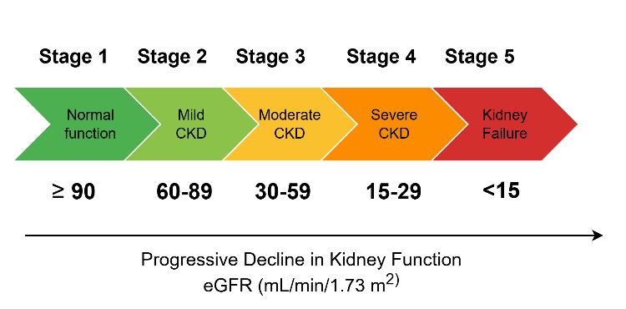
Fig. 1. Progression of Chronic Kidney Disease (CKD) based on estimated glomerular filtration rate (eGFR).
The standard diagnosis of CKD relies on laboratory assessment of biomarkers such as serum creatinine, estimated GFR, blood urea nitrogen and urine albumin to creatinine ratio. Although effective, this approach can be time consuming, requires skilled interpretation and may be difficult to scale in resource-limited settings. Machine learning (ML) provides an alternative by learning complex relationships between clinical features and CKD outcomes from historical data [11]. Since 2016, CKD prediction research has evolved from classical classifiers such as KNN, SVM and decision trees to ensemble methods, deep-learning and more recently hybrid and explainable AI approaches. However, differences datasets, preprocessing and evaluation settings make direct comparison of reported results difficult. This review therefore examines CKD prediction research from 2016 to 2026 [6], [17], highlighting major methodological trends, performance and research gaps.

1.1 Contributions of This Review
This review categorizes CKD prediction studies from 2016-2026 into classical, ensemble, deep-learning, and explainable approaches. It compares datasets, preprocessing, feature-selection methods, and reported performance while identifying major challenges and future research directions [7].

2. Review Methodology

The review follows the Preferred Reporting Items for Systematic Reviews and Meta-Analyses (PRISMA) framework to identify, screen. And select machine-learning based CKD prediction studies published between 2026 and mid-2026 [17].

2.1 Search Strategy
A structured search was conducted in IEEE Xplore, Scopus, PubMed, ScienceDirect, and ACM Digital Library using combinations of keywords including chronic kidney disease, machine learning, deep learning, ensemble learning, CKD prediction, and explainable AI. Reference-list snowballing and targeted Google Scholar searches were also used to identify additional studies.

2.2 Eligibility Criteria

Studies were included if they: (i) used machine/deep learning to predict, classify, or stage CKD or related renal outcomes; (ii) reported at least one quantitative metric such as accuracy, AUC, or F1-score; and (iii) were peer-reviewed journal or conference publications. Studies without sufficient methodological detail, purely clinical/epidemiological studies, duplicates or overlapping analyses without new methodological contributions, and studies not focused on CKD prediction were excluded [11].

2.3 Study Selection and Data Extraction
Study selection followed the PRISMA process shown in Figure 2. Retrieved records were screened, de-duplicated, and assessed through full-text review against the eligibility criteria. For included studies, data on datasets, preprocessing and feature selection, algorithm families, and best reported performance were extracted for qualitative synthesis.

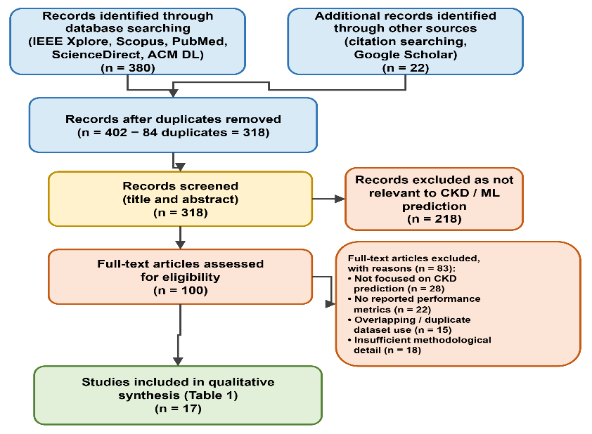
Fig. 2. PRISMA flow diagram of the literature identification, screening, eligibility, and inclusion process used in this review.

3. Related Work

3.1 Early Foundational Studies (2016–2018)
Early studies (2016-2018) primarily applied classical classifiers such as SVM, KNN, logistics regression, and decision trees, predominantly using the UCI CKD dataset [1]. Feature-selection techniques were introduces to improve classifier performance, establishing a benchmark for subsequent research.

3.2 Growth Phase: Ensemble and Early Deep Learning (2019–2022)
During 2019-2022, research increasingly adopted ensemble methods and early deep-learning approaches. Studies also began using insurance claims and electronic health records, moving beyond the small UCI benchmark [8],[12].

3.3 Maturity Phase: Hybrid and Explainable Systems (2023–2026)
From 2023 onward, research has increasingly focused on hybrid deep-ensemble models, feature fusion, explainable AI, and real-world clinical datasets. Recent work emphasizes generalizability and interpretability rather than accuracy alone.

Table 1. Summary of Representative CKD Prediction Studies (2016–2026)
Ref. | Study Focus / Algorithm(s) | Dataset | Best Result
[6] | Charleonnan et al. (2016) — KNN, SVM, LR, DT comparLR, DT comparison | UCI CKD | SVM top classifier
[7] | Polat et al. (2017) — SVM with wrapper feature selection | UCI CKD | High diagnostic accuracy
[8] | Amirgaliyev et al. (2018) — Multi-classifier CKD analysis | UCI CKD | Improved over baselines
[9] | Chen et al. (2020) — Hybridized deep CNN on IoMT platform | IoMT clinical data | Accuracy 96.8%
[10] | Chittora et al. (2021) — LSVM, ANN, KNN with feature selection | UCI CKD | Accuracy 99.75%
[11] | Krishnamurthy et al. (2021) — ML for CKD outcome prediction | National insurance claims | AUC 0.85
[12] | Saif et al. (2023) — Deep-kidney ensemble framework | UCI CKD | Accuracy 99.0%
[13] | Saif et al. (2024) — Ensemble of deep learning + optimizers | UCI CKD | Accuracy 99.31%
[14] | Ghosh & Khandoker (2024) — Explainable ML (XGBoost, RF, LR) | Clinical dataset (n=491) | Accuracy 96.7%
[15] | Khan (2025) — multi-level feature-fusion network | Multi-source clinical data | Improved fusion accuracy
[16] | Jospiene et al. (2026) — ML for CKD progression analysis | Real-world hospital dataset | Improved progression accuracy

Ensemble approaches, random forest, extra-trees, and gradient-boosting variations compete with, and often outperform, single classical classifiers. Deep-learning and hybrid ensemble-deep systems often get the greatest scores, usually exceeding 98%, but at a cost: more computation and models that are more difficult to dissect and comprehend [17]. That trade-off is receiving greater attention today. Beginning in 2023, SHAP and LIME have appeared in an increasing number of studies.

4. CKD Dataset Description
Chronic Kidney Disease (CKD) datasets are crucial for developing and testing computational techniques for identifying and forecasting disease. Usually, CKD data sets include demographic, clinical, and laboratory information such as age, blood pressure, blood glucose, albumin, serum, creatinine, haemoglobin, electrolyte and other clinically relevant attributes. The outcome is typically the presence or absence of CKD. In summary, CKD datasets offer valuable resources for the evaluation, comparison, analysis, and identification of existing prediction methods, as well as gaps or areas for future study.
Table 2. CKD Dataset Description
S. No. | Dataset | Description
1. | UCI Chronic Kidney Disease Dataset [1] | Benchmark clinical dataset containing 400 patient records with 24 clinical attributes collected from a hospital in Tamil Nadu, India.
2. | Kaggle Chronic Kidney Disease Dataset [2] | Mirror of the UCI CKD dataset available on Kaggle for easy access and preprocessing.
3. | NHANES Kidney Disease Dataset [3] | Population-based health survey dataset containing demographic, laboratory, nutrition, and kidney-related biomarkers for CKD risk assessment.
4. | MIMIC-IV Dataset [4] | Large-scale ICU electronic health record database containing laboratory measurements, diagnoses, medications, and kidney function variables for CKD and AKI research.
5. | eICU Collaborative Research Database [19] | Multi-center critical care database from hospitals across the United States with comprehensive laboratory and physiological measurements.

In addition to the UCI benchmark, various studies conducted after 2021 have utilized hospital-specific EHRs [18], national insurance-claim databases, and multi-center cohorts. This is due in part to the desire to test generalizability on more realistic and messy data, and in part to the desire to model the progression of CKD over time rather than relying on the classification of a single snapshot.

5. Machine Learning Methodology
Figure 3 shows the overall process flow of these ML-based CKD systems. Clinical records or an electronic health record system provide the data. The collected data undergo preprocessing. Relevant features are then selected [17]. Class imbalance is addressed using appropriate balancing techniques. With the addition of an explainability phase, the model goes from training to evaluation to prediction.

5.1 Data Pre-processing
A significant portion of the CKD dataset at UCI is missing. Up to 38% of entries lack certain features. Preprocessing commonly involves missing-value imputation, categorical encoding, and numerical normalization. Methods include MICE, KNN imputation, label encoding, and one-hot encoding [10].

5.2 Feature Selection
Eliminating superfluous or useless features from the feature set improves generalization and performance. Feature selection methods include PCA, chi-square testing, correlation filtering, and mutual-information-based approaches [13].

5.3 Class Imbalance Handling
In contrast to healthy control groups, clinical CKD databases often have a lower number of positive cases. Class imbalance is addressed using oversampling, SMOTE, or ADASYN, or cost-sensitive learning to reduce majority bias [21].

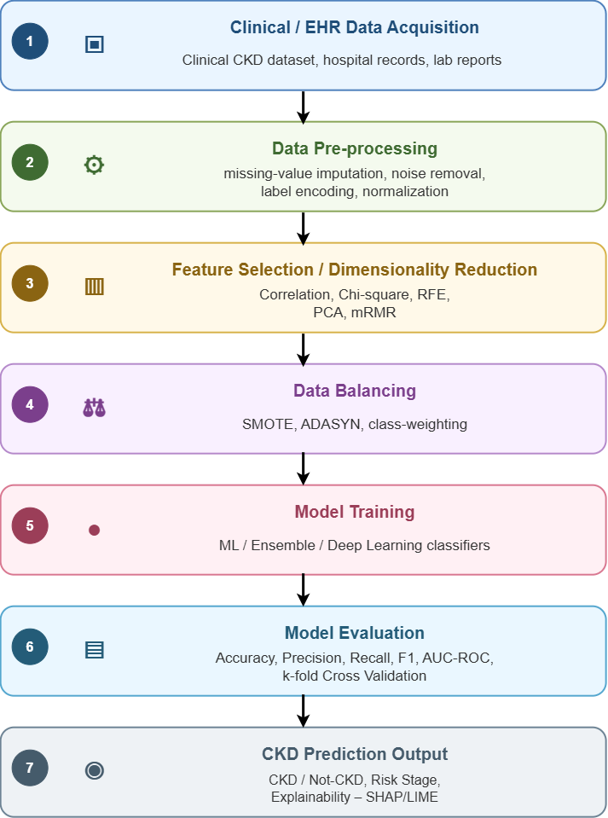
Fig. 3. General Workflow of a Machine-Learning-Based CKD Prediction System

6. Taxonomy of ML Algorithms For CKD Prediction
Fig. 4 classifies the techniques found in this literature into four groups: traditional supervised models, ensemble approaches, deep-learning architectures, and hybrid or explainable artificial intelligence systems.

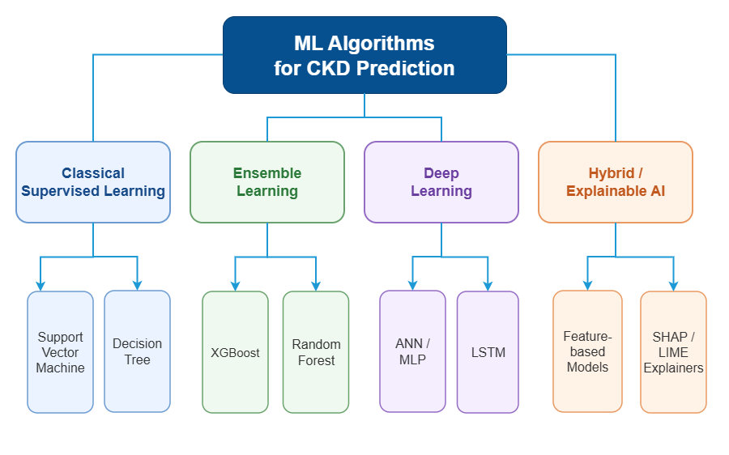
Fig. 4. Taxonomy of Machine-Learning Algorithms Applied To CKD Prediction

6.1 Classical Supervised Learning
This category includes logistic regression, KNN, SVM, decision trees, and Naive Bayes. They are computationally efficient and interpretable but may have limitations with complex nonlinear patterns [10].

6.2 Ensemble Learning
This category includes XGBoost, gradient boosting, AdaBoost, random forest, and extra-trees. The ensemble methods stand out as the most effective among all the options discussed here. On the UCI dataset, they often achieve 98% accuracy [22].

6.3 Deep Learning
This category includes Artificial Neural Network (ANN), Multilayer Perceptron (MLP), Convolution Neural Network (CNN), and more. These models are great at detecting non-linear patterns but generally require larger datasets and offer low interpretability [21].

6.4 Hybrid and Explainable AI Approaches
Recent studies combine model families, stacked ensembles, feature-fusion networks, and explainability methods like SHAP or LIME to improve predictive performance and interpretability [20], [22]. One of the major challenges of using these technologies in a healthcare facility is achieving a balance between predictive accuracy and model interpretability.

7. Evaluation Metrics
Evaluation metrics are key to evaluating the performance, reliability, and clinical relevance of machine learning (ML) and deep learning (DL) models in the diagnosis and prediction of chronic kidney disease (CKD). CKD prediction studies commonly report accuracy, precision, recall, sensitivity, F1-score, and ROC-AUC [18]. Because CKD datasets maybe imbalanced, accuracy alone can be misleading: therefore, sensitivity, specificity, F1-score, and AUC provides complementary measures. Sensitivity is particularly important because false negative may delay diagnosis.

8. Challenges and Future Research Directions
Challenge | Future Direction
Class imbalance | Advanced sampling/ cost-negative learning [21]
Missing/noisy data | Robust preprocessing
Limited external validation | Multi-center datasets
Interpretability | SHAP, LIME, attention [22]
Privacy | Federated Learning
Limited modalities | Multimodal fusion

10. Conclusion
The present review examined CKD prediction research from 2016-2022 and categorized existing approaches into classical, ensemble, deep-learning, and hybrid/explainable models. The literature shows a transition from small benchmark datasets and conventional classifiers towards ensemble, deep-learning, explainable, and real-world clinical approaches [20]. However, limited external validation, dataset, heterogeneity, privacy constraints, and interpretability remain important challenges. Future research should emphasize multi0center datasets, federated learning, explainable AI, multimodal integration, and longitudinal CKD progression.
References
1. L. Rubini, P. Soundarapandian, and P. Eswaran, Chronic Kidney Disease Dataset, UCI Machine Learning Repository, 2015, doi: 10.24432/C5G020
2. R.K. Halder,M.N. Uddin,M.A. Uddin,S.Aryal,S. Saha, R.Hossen, S.Ahmed, M.A. T. Rony, and M. F. Akter,”ML-CKDP:Machine Learning-based chronic kidney disease prediction with smart web application”,J.Pathol.Inform.,vol.15,p.100371,2024,doi:10.1016/j.jpi.2024.100371.
3. Centers for Disease Control and Prevention, National Health and Nutrition Examination Survey (NHANES). Available: https://www.cdc.gov/nchs/nhanes/. (Official Dataset Reference)
4. A.E.W. Johnson et al., “MIMIC-IV, a freely accessible electronic health record dataset,” Scientific Data, vol. 10, 2023
5. S. Singamsetty, S.Biswas, and A.Pradhan,”Enhancing machine learning-based forecasting of chronic renal disease with explainable AI”, PeerJ Comput.Sci., vol. 10, p.e2291, 2024, doi: 10.7717/peerj-cs.2291.
6. A. Charleonnan, T. Fufaung, T. Niyomwong, W. Chokchueypattanakit, S. Suwannawach, and N. Ninchawee, "Predictive analytics for chronic kidney disease using machine learning techniques," in Proc. 2016 Manage. Innov. Technol. Int. Conf. (MITicon), 2016, pp. MIT-80–MIT-83.
7. H. Polat, H. Danaei Mehr, and A. Cetin, "Diagnosis of chronic kidney disease based on support vector machine by feature selection methods," J. Med. Syst., vol. 41, pp. 1–11, 2017.
8. Y. Amirgaliyev, S. Shamiluulu, and A. Serek, "Analysis of chronic kidney disease dataset by applying machine learning methods," in Proc. 2018 IEEE 12th Int. Conf. Appl. Inf. Commun. Technol. (AICT), 2018, pp. 1–4.
9. G. Chen, C. Ding, Y. Li, X. Hu, X. Li, L. Ren, X. Ding, P. Tian, and W. Xue, "Prediction of chronic kidney disease using adaptive hybridized deep convolutional neural network on the internet of medical things platform," IEEE Access, vol. 8, pp. 100497–100508, 2020.
10. P. Chittora, S. Chaurasia, P. Chakrabarti, et al., "Prediction of Chronic Kidney Disease – A Machine Learning Perspective," IEEE Access, vol. 9, pp. 17312–17334, 2021
11. V. Krishnamurthy, A. Gopal, R. Kannan, et al., "Machine learning for predicting outcomes in chronic kidney disease: Challenges and opportunities," IEEE J. Biomed. Health Inform., vol. 25, no. 4, pp. 1319–1331, 2021.
12. D. Saif, A. M. Sarhan, and N. M. Elshennawy, "Deep-kidney: an effective deep learning framework for chronic kidney disease prediction," Netw. Model. Anal. Health Inform. Bioinform., vol. 12, art. 60, 2023, doi: 10.1007/s13755-023-00261-8.
13. D. Saif, A. M. Sarhan, and N. M. Elshennawy, "Early prediction of chronic kidney disease based on ensemble of deep
learning models and optimizers," J. Electr. Syst. Inf. Technol., vol. 11, no. 1, art. 17, 2024.
14. S. K. Ghosh and A. H. Khandoker, "Investigation on explainable machine learning models to predict chronic kidney diseases," Sci. Rep., vol. 14, art. 3687, 2024.
15. S. U. Khan, "Multi-level feature fusion network for kidney disease detection," Comput. Biol. Med., vol. 191, art. 110214, 2025.
16. E. J. M, N. S, S. Bag, S. Elavarasan, P. Ghosh, M. Sathiyamoorthy, and S. T. Gopukumar, "Machine Learning Algorithms for Predicting CKD Progression: A Real-World Hospital Dataset Analysis," KIDNEYS, vol. 15, no. 1, pp. 43–54, 2026.
15. J. J. Niveda and R. Y. Rajkumar, "Comparative Analysis of Machine Learning Algorithms for Early Detection of Chronic Kidney Disease: Performance Evaluation and Insights," in Proc. 2024 3rd Int. Conf. Smart Technol. Syst. Next Gen. Comput. (ICSTSN), 2024, pp. 1–6, doi: 10.1109/ICSTSN61422.2024.10671021.
18. T.J. Pollard et al., “The eICU Collaborative Research Database, a freely available multi-center database for critical care research”, Scientific Data, vol. 5, art. 180178, 2018.
19. H.I. Feldman et al., “The Chronic Renal Insuffeciency Cohort(CRIC) Study:Design and methods,” Journal of the American Society of Nephrology, vol.14, no.7,pp.S148-S153, 2003
20. B. Anoch and L. Parthiban, “Uncertainty-aware AI for enhanced chronic kidney disease diagnosis: a review of explainable and reliable models,” in Proc. 2025 Int. Conf. Comput. Robot. Testing Eng. Eval. (ICCRTEE), IEEE, 2025, pp. 1–6.
21. Ebiaredoh-Mienye, S.A., Swart, T.G., Esenogho, E., Esenogho, F., & Mienye, I.D. (2023). “SMOTE-ENN- Based Data Sampling and Improved Machine Learning Models for Chronic Kidney Disease Diagnosis.” Diagnostics, 13(11), 1828.
22. K. Venkatrao and K. Shaik, “HDLNet: a hybrid deep learning network model with intelligent IoT for detection and classification of chronic kidney disease,” IEEE Access, vol. 11, pp. 99638–99652, 2023.

